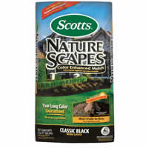

Nature Scapes Mulch
- 2 Cubic Feet Coverage
- Color Enhanced
#28
- Color Guard brand
- Prevents weeds naturally

$4.99
7269483

